QUALCOMM Equipment
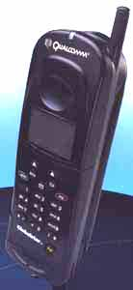
GSP 1600 Tri-Mode Phone
Globalstar Tri-Mode Phones from QUALCOMM are designed with the flexibility to meet the needs of cellular users who already consume a high volume of airtime, but find themselves in areas where cellular coverage is either unavailable, incompatible or inaccessible. QUALCOMM's Globalstar Tri-Mode Phone is designed to compliment existing fixed and cellular telephone networks by switching from terrestrial cellular telephony to satellite telephony as required. Interoperability between the Globalstar communications system and cellular Service Providers is assured. These features provide the Globalstar user the highest level of service and convenience, which increases subscriber's satisfaction and loyalty to the cellular Service Provider.
High Capacity Polymer Lithium Ion Battery Pack
This high capacity battery pack enables talk and standby times that more than double those of the standard battery pack. Up to 3.5 hours talk time and 9 hours standby in Globalstar mode; 4.5 hours talk time, 72 hours standby in CDMA cellular mode; 2.5 hours talk time, 14 hours standby in AMPS cellular mode.
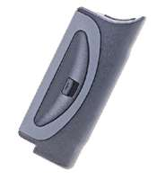
Cigarette Lighter Adapter / Charger
Stuck in traffic with a low battery? Not a problem. The cigarette lighter adapter lets you use the car battery to power your phone. Charge time is about one hour.
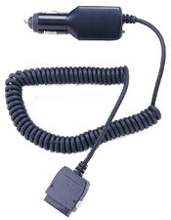
Wall Chargers
Provide rapid charging capability for the Qualcomm mobile phone, with either a European or a North American electrical adapter.

